# Spring Rest HandsOn

**Hands on 1**

**Create a Spring Web Project using Maven** 

pom.xml

<?xml version="1.0" encoding="UTF-8"?>

<project xmlns="http://maven.apache.org/POM/4.0.0" xmlns:xsi="http://www.w3.org/2001/XMLSchema-instance"

xsi:schemaLocation="http://maven.apache.org/POM/4.0.0 https://maven.apache.org/xsd/maven-4.0.0.xsd">

<modelVersion>4.0.0</modelVersion>

<parent>

<groupId>org.springframework.boot</groupId>

<artifactId>spring-boot-starter-parent</artifactId>

<version>3.5.3</version>

<relativePath/> <!-- lookup parent from repository -->

</parent>

<groupId>com.cognizant</groupId>

<artifactId>spring-learn</artifactId>

<version>0.0.1-SNAPSHOT</version>

<name>spring-learn</name>

<description>Demo project for learning Spring</description>

<url/>

<licenses>

<license/>

</licenses>

<developers>

<developer/>

</developers>

<scm>

<connection/>

<developerConnection/>

<tag/>

<url/>

</scm>

<properties>

<java.version>17</java.version>

</properties>

<dependencies>

<dependency>

<groupId>org.springframework.boot</groupId>

<artifactId>spring-boot-starter-web</artifactId>

</dependency>

<dependency>

<groupId>org.springframework.boot</groupId>

<artifactId>spring-boot-devtools</artifactId>

<scope>runtime</scope>

<optional>true</optional>

</dependency>

<dependency>

<groupId>org.springframework.boot</groupId>

<artifactId>spring-boot-starter-test</artifactId>

<scope>test</scope>

</dependency>

</dependencies>

<build>

<plugins>

<plugin>

<groupId>org.springframework.boot</groupId>

<artifactId>spring-boot-maven-plugin</artifactId>

</plugin>

</plugins>

</build>

</project>

Folder structure:

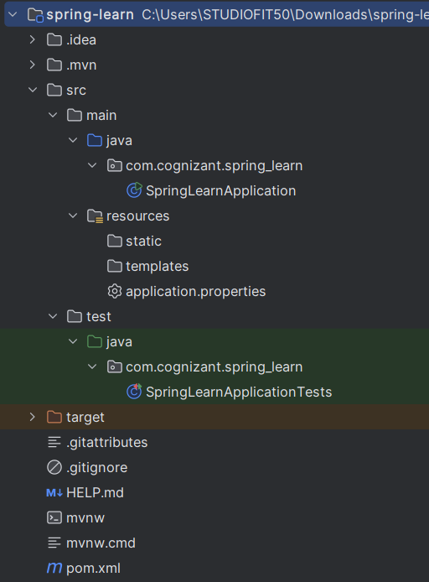

SpringLearnApplication.java

package com.cognizant.spring_learn;

import org.slf4j.Logger;

import org.slf4j.LoggerFactory;

import org.springframework.boot.SpringApplication;

import org.springframework.boot.autoconfigure.SpringBootApplication;

@SpringBootApplication

public class SpringLearnApplication {

private static final Logger LOGGER = LoggerFactory.getLogger(SpringLearnApplication.class);

public static void main(String[] args) {

SpringApplication.run(SpringLearnApplication.class, args);

LOGGER.info("Inside main()");

}

}

Output:

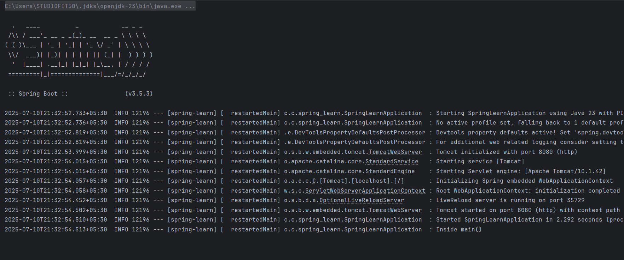

**Hands on 2**

# **Spring Core – Load SimpleDateFormat from Spring Configuration XML**

src/main/resources/date-format.xml

<?xml version="1.0" encoding="UTF-8"?>

<beans xmlns="http://www.springframework.org/schema/beans"

xmlns:xsi="http://www.w3.org/2001/XMLSchema-instance"

xsi:schemaLocation="http://www.springframework.org/schema/beans

https://www.springframework.org/schema/beans/spring-beans.xsd">

<bean id="dateFormat" class="java.text.SimpleDateFormat">

<constructor-arg value="dd/MM/yyyy" />

</bean>

<!-- more bean definitions go here -->

</beans>

SpringLearnApplication.java

package com.cognizant.spring_learn;

import org.slf4j.Logger;

import org.slf4j.LoggerFactory;

import org.springframework.boot.SpringApplication;

import org.springframework.boot.autoconfigure.SpringBootApplication;

import org.springframework.context.ApplicationContext;

import org.springframework.context.support.ClassPathXmlApplicationContext;

import java.text.ParseException;

import java.text.SimpleDateFormat;

import java.util.Date;

@SpringBootApplication

public class SpringLearnApplication {

private static final Logger LOGGER = LoggerFactory.getLogger(SpringLearnApplication.class);

public static void main(String[] args) throws ParseException {

SpringApplication.run(SpringLearnApplication.class, args);

LOGGER.info("Inside main()");

System.out.println();

displayDate("31/12/2018");

}

public static void displayDate(String date) throws ParseException {

ApplicationContext context = new ClassPathXmlApplicationContext("date-format.xml");

SimpleDateFormat format = context.getBean("dateFormat", SimpleDateFormat.class);

Date inp = format.parse(date);

System.out.println("Parsed Date: " + inp);

}

}

Output:

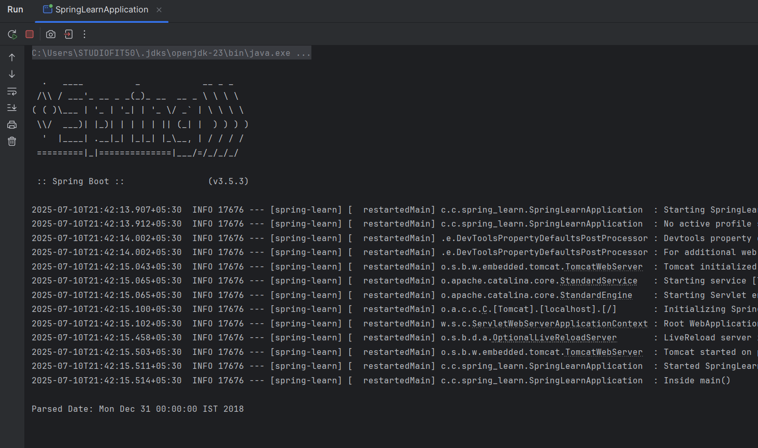

**Hands on 3**

**Spring Core - Incorporate Logging** 

src/main/resources/application.properties

spring.application.name=spring-learn

logging.level.org.springframework=info

logging.level.com.cognizant.springlearn=debug

logging.pattern.console=%d{yyMMdd}|%d{HH:mm:ss.SSS}|%-20.20thread|%5p|%-25.25logger{25}|%25M|%m%n

SpringLearnApplication.java

package com.cognizant.springlearn;

import org.slf4j.Logger;

import org.slf4j.LoggerFactory;

import org.springframework.boot.SpringApplication;

import org.springframework.boot.autoconfigure.SpringBootApplication;

import org.springframework.context.ApplicationContext;

import org.springframework.context.support.ClassPathXmlApplicationContext;

import java.text.ParseException;

import java.text.SimpleDateFormat;

import java.util.Date;

@SpringBootApplication

public class SpringLearnApplication {

private static final Logger LOGGER = LoggerFactory.getLogger(SpringLearnApplication.class);

public static void main(String[] args) throws ParseException {

SpringApplication.run(SpringLearnApplication.class, args);

LOGGER.info("START");

Date date = displayDate("31/12/2018");

LOGGER.debug("Parsed Date = {}", date);

LOGGER.info("END");

}

public static Date displayDate(String date) throws ParseException {

ApplicationContext context = new ClassPathXmlApplicationContext("date-format.xml");

SimpleDateFormat format = context.getBean("dateFormat", SimpleDateFormat.class);

Date inp = format.parse(date);

return inp;

}

}

Output:  
  
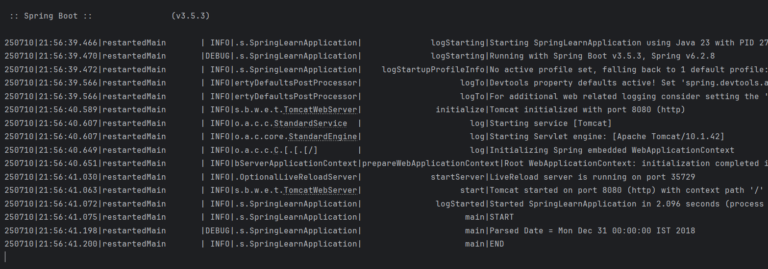

**Hands on 4**

**Spring Core – Load Country from Spring Configuration XML** 

country.xml

<?xml version="1.0" encoding="UTF-8"?>

<beans xmlns="http://www.springframework.org/schema/beans"

xmlns:xsi="http://www.w3.org/2001/XMLSchema-instance"

xsi:schemaLocation="http://www.springframework.org/schema/beans

https://www.springframework.org/schema/beans/spring-beans.xsd">

<bean id="country" class="com.cognizant.springlearn.Country">

<property name="code" value="IN" />

<property name="name" value="India" />

</bean>

</beans>

Country.java

package com.cognizant.springlearn;

import org.slf4j.Logger;

import org.slf4j.LoggerFactory;

public class Country {

private static final Logger LOGGER = LoggerFactory.getLogger(Country.class);

private String code;

private String name;

public Country() {

LOGGER.debug("Inside Country Constructor");

}

public String getCode() {

LOGGER.debug("Inside getCode");

return code;

}

public void setCode(String code) {

LOGGER.debug("Inside setCode");

this.code = code;

}

public String getName() {

LOGGER.debug("Inside getName");

return name;

}

public void setName(String name) {

LOGGER.debug("Inside setName");

this.name = name;

}

@Override

public String toString() {

return "Country [code=" + code + ", name=" + name + "]";

}

}

SpringLearnApplication.java

package com.cognizant.springlearn;

import org.slf4j.Logger;

import org.slf4j.LoggerFactory;

import org.springframework.boot.SpringApplication;

import org.springframework.boot.autoconfigure.SpringBootApplication;

import org.springframework.context.ApplicationContext;

import org.springframework.context.support.ClassPathXmlApplicationContext;

import java.text.ParseException;

import java.text.SimpleDateFormat;

import java.util.Date;

@SpringBootApplication

public class SpringLearnApplication {

private static final Logger LOGGER = LoggerFactory.getLogger(SpringLearnApplication.class);

public static void main(String[] args) throws ParseException {

SpringApplication.run(SpringLearnApplication.class, args);

LOGGER.info("START");

displayDate("31/12/2018");

displayCountry();

LOGGER.info("END");

}

public static void displayDate(String date) throws ParseException {

ApplicationContext context = new ClassPathXmlApplicationContext("date-format.xml");

SimpleDateFormat format = context.getBean("dateFormat", SimpleDateFormat.class);

Date inp = format.parse(date);

LOGGER.debug("Parsed Date = {}", inp);

}

public static void displayCountry() {

ApplicationContext context = new ClassPathXmlApplicationContext("country.xml");

Country country = context.getBean("country", Country.class);

LOGGER.debug("Country : {}", country.toString());

}

}

Output:

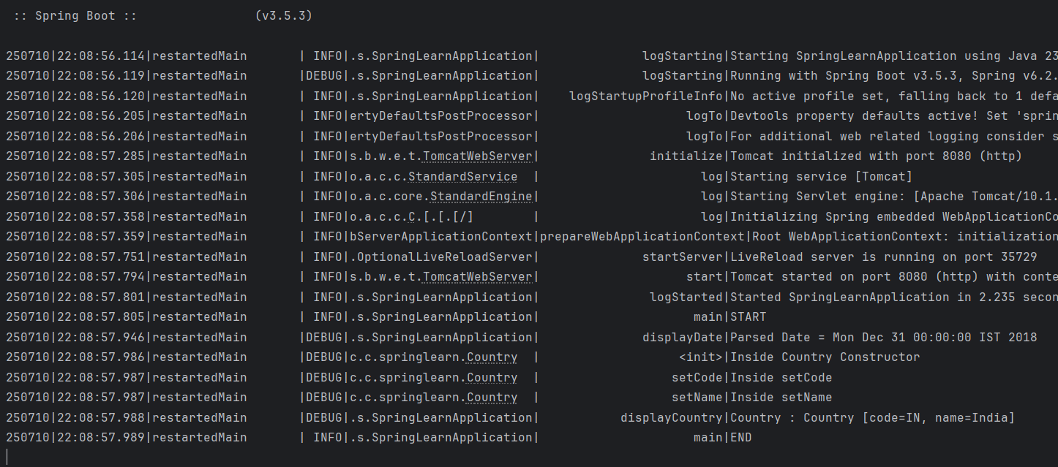

**Hands on 5**

**Spring Core – Demonstration of Singleton Scope and Prototype Scope**

SpringLearnApplication.java

package com.cognizant.springlearn;

import org.slf4j.Logger;

import org.slf4j.LoggerFactory;

import org.springframework.boot.SpringApplication;

import org.springframework.boot.autoconfigure.SpringBootApplication;

import org.springframework.context.ApplicationContext;

import org.springframework.context.support.ClassPathXmlApplicationContext;

import java.text.ParseException;

import java.text.SimpleDateFormat;

import java.util.Date;

@SpringBootApplication

public class SpringLearnApplication {

private static final Logger LOGGER = LoggerFactory.getLogger(SpringLearnApplication.class);

public static void main(String[] args) throws ParseException {

SpringApplication.run(SpringLearnApplication.class, args);

LOGGER.info("START");

displayDate("31/12/2018");

displayCountry();

LOGGER.info("END");

}

public static void displayDate(String date) throws ParseException {

ApplicationContext context = new ClassPathXmlApplicationContext("date-format.xml");

SimpleDateFormat format = context.getBean("dateFormat", SimpleDateFormat.class);

Date inp = format.parse(date);

LOGGER.debug("Parsed Date = {}", inp);

}

public static void displayCountry() {

ApplicationContext context = new ClassPathXmlApplicationContext("country.xml");

Country country = context.getBean("country", Country.class);

Country anotherCountry = context.getBean("country", Country.class);

LOGGER.debug("Country : {}", country.toString());

}

}

country.xml

<?xml version="1.0" encoding="UTF-8"?>  
<beans xmlns="http://www.springframework.org/schema/beans"  
 xmlns:xsi="http://www.w3.org/2001/XMLSchema-instance"  
 xsi:schemaLocation="http://www.springframework.org/schema/beans  
 https://www.springframework.org/schema/beans/spring-beans.xsd">  
  
 <bean id="country" class="com.cognizant.springlearn.Country" scope="prototype">  
 <property name="code" value="IN" />  
 <property name="name" value="India" />  
 </bean>  
  
</beans>

Output:

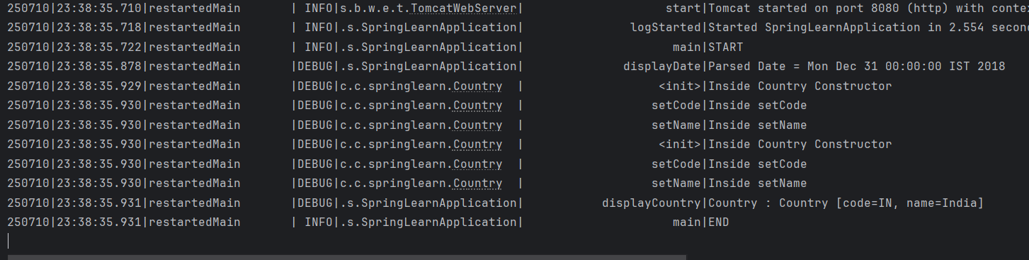

**Hands on 6**

**Spring Core – Load list of countries from Spring Configuration XML**

country.xml

<?xml version="1.0" encoding="UTF-8"?>

<beans xmlns="http://www.springframework.org/schema/beans"

xmlns:xsi="http://www.w3.org/2001/XMLSchema-instance"

xsi:schemaLocation="http://www.springframework.org/schema/beans

https://www.springframework.org/schema/beans/spring-beans.xsd">

<bean id="country" class="com.cognizant.springlearn.Country" scope="prototype">

<property name="code" value="IN" />

<property name="name" value="India" />

</bean>

<bean id="in" class="com.cognizant.springlearn.Country">

<property name="code" value="IN" />

<property name="name" value="India" />

</bean>

<bean id="us" class="com.cognizant.springlearn.Country">

<property name="code" value="US" />

<property name="name" value="United States" />

</bean>

<bean id="de" class="com.cognizant.springlearn.Country">

<property name="code" value="DE" />

<property name="name" value="Germany" />

</bean>

<bean id="jp" class="com.cognizant.springlearn.Country">

<property name="code" value="JP" />

<property name="name" value="Japan" />

</bean>

<bean id="countryList" class="java.util.ArrayList">

<constructor-arg>

<list>

<ref bean="in"></ref>

<ref bean="us"></ref>

<ref bean="de"></ref>

<ref bean="jp"></ref>

</list>

</constructor-arg>

</bean>

</beans>

SpringLearnApplication.java

package com.cognizant.springlearn;

import org.slf4j.Logger;

import org.slf4j.LoggerFactory;

import org.springframework.boot.SpringApplication;

import org.springframework.boot.autoconfigure.SpringBootApplication;

import org.springframework.context.ApplicationContext;

import org.springframework.context.support.ClassPathXmlApplicationContext;

import java.text.ParseException;

import java.text.SimpleDateFormat;

import java.util.ArrayList;

import java.util.Date;

import java.util.List;

@SpringBootApplication

public class SpringLearnApplication {

private static final Logger LOGGER = LoggerFactory.getLogger(SpringLearnApplication.class);

public static void main(String[] args) throws ParseException {

SpringApplication.run(SpringLearnApplication.class, args);

LOGGER.info("START main");

// displayDate("31/12/2018");

// displayCountry();

displayCountries();

LOGGER.info("END main");

}

public static void displayDate(String date) throws ParseException {

LOGGER.info("START displayDate");

ApplicationContext context = new ClassPathXmlApplicationContext("date-format.xml");

SimpleDateFormat format = context.getBean("dateFormat", SimpleDateFormat.class);

Date inp = format.parse(date);

LOGGER.debug("Parsed Date = {}", inp);

LOGGER.info("END displayDate");

}

public static void displayCountry() {

LOGGER.info("START displayCountry");

ApplicationContext context = new ClassPathXmlApplicationContext("country.xml");

Country country = context.getBean("country", Country.class);

Country anotherCountry = context.getBean("country", Country.class);

LOGGER.debug("Country : {}", country.toString());

LOGGER.info("END displayCountry");

}

public static void displayCountries() {

LOGGER.info("START displayCountries()");

ApplicationContext context = new ClassPathXmlApplicationContext("country.xml");

List<Country> countries = context.getBean("countryList", List.class);

LOGGER.debug("List of Countries: {}", countries);

LOGGER.info("END displayCountries()");

}

}

Output:

